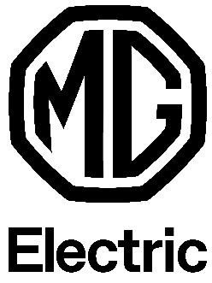
MG EHS Plug-in Hybrid: the ideal beginning of an electric lifestyle
MG’s new model in the spotlight in the festive days of December

Amsterdam, November 30th 2020 – After the successful roll-out of the 100% electric MG ZS EV, MG will officially launch its second model in Europe, the MG EHS Plug-in Hybrid, on December 7th. With the reference to ‘Electric’ in the name, MG emphasizes its commitment to making electric mobility accessible to all European drivers who are young at heart, motivated to change the world around them, and ready to embark on their new electric lifestyle.
The well-designed, environmentally conscious SUV is of high quality, safe, readily available and offered with advanced technology at a fair price. The MG EHS Plug-in Hybrid allows drivers who are not yet ready for a fully electric car to drive electrically and sustainably, without having to worry about the range.
During the festive but also dark days in December, the MG EHS Plug-in Hybrid will literally be put in the spotlights in a playful way. A festively decorated MG Christmas truck will tour the new model in Europe.
Now that we are mostly at home, MG is coming to Europe in both a factual and a metaphorical sense. In new countries such as Germany, Sweden, Italy, Spain and Portugal, where MG will soon enter the market, but also in countries where the MG ZS EV is already available: France, The Netherlands, Belgium, Luxembourg, Norway, Denmark, Iceland and Austria.
- END -
Note to the editors:
If you would like to join the digital launch of the MG EHS Plug-in Hybrid on December 7th at 11:00 a.m. and you haven’t let us know yet, we would love to hear from you. You are cordially invited to attend our launch, and can easily do so by using this link!
About MG - we have a long history
MG has always been ahead of its time since the brand was founded in Morris Garages in 1924. Now a new generation can choose a car of this iconic brand. Redesigned, electric and ready for the future. MG makes electric driving accessible to everyone. With the already proven success of the 100% electric ZS EV and the announcement of several sustainable vehicles in the coming years, MG is demonstrating its full commitment to electric mobility. Designed with the European motorist in mind, MG offers durable, smart, functional and affordable vehicles. MG is being developed in the company's design studios in Shanghai, in collaboration with the advanced design studio in London. MG is produced in China and already available in several European countries.

For further information:
Mike Belinfante
Senior Manager Public Relations
MG Motor Europe
12 Professor W.H. Keesomlaan, Amstelveen
The Netherlands
Mobile: +31 (0) 5 177 6699
mike.belinfante@mgmotor.eu

